Suffolk County Scout Council
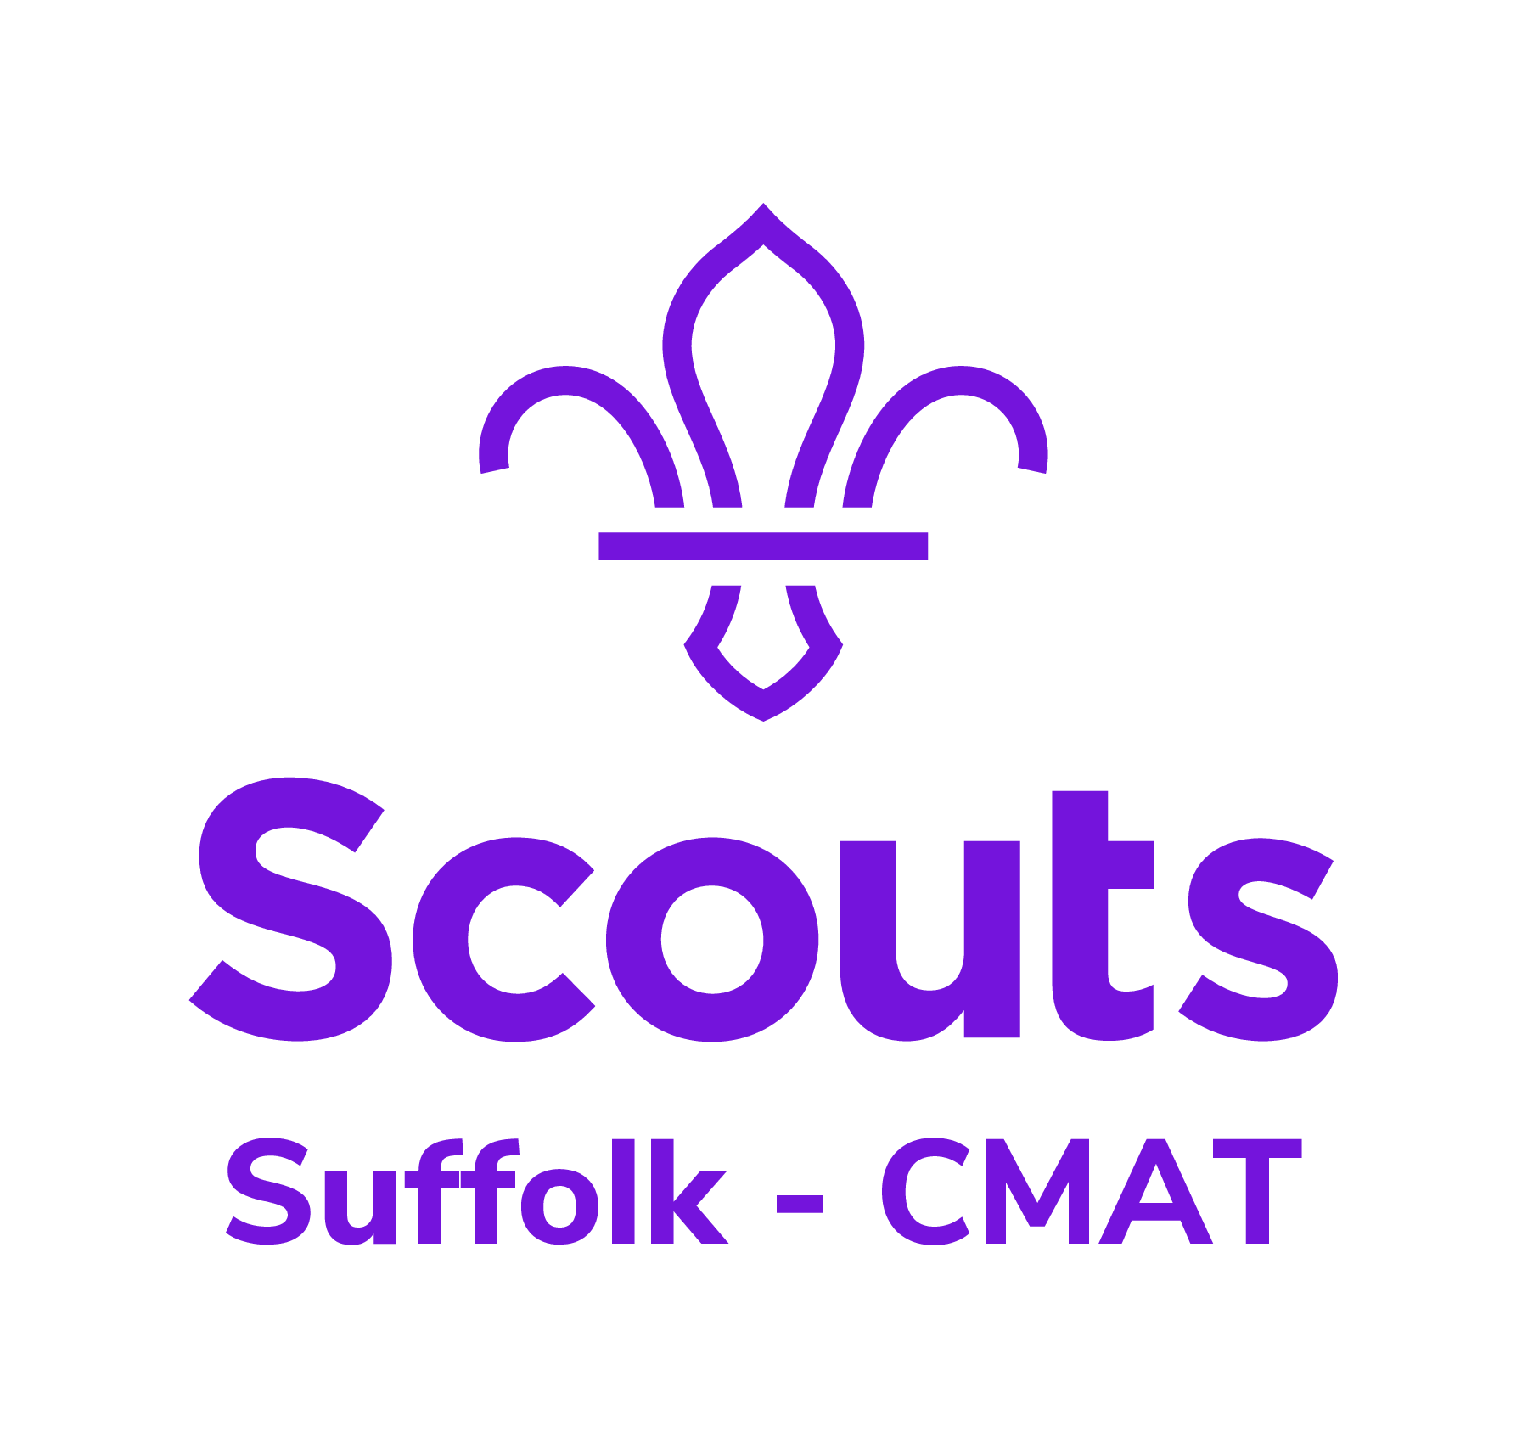
Registered Charity number 305682

County Mountain Activities Team

Rock Climbing event based at Glenbrook Outdoor Activities Centre, Hope Road, Hope Valley, Bamford (near Hathersage) S33 0AL
Fri 24 9 21 to Sun 26 9 21 (arriving Fri night 24th)

In the event of a child / adult contracting Covid while on this trip, Units and Groups should make their own arrangements to have that person collected from the venue asap.
Please make arrangements to take a rapid flow test one day before and one day after the event. (Let us know asap in the event of a positive test). Bring a face covering and hand gel with you to the venue. Ventilation and hand hygiene precautions will be in place.

- For Scouts (minimum age 11 years) Explorer Scouts, Network and Leaders, Assistant Leaders, Section/Unit Assistants and other approved adults.

- Scouts should ideally be accompanied by a Troop Leader or approved adult. There are a limited number of places available to unaccompanied Scouts and bookings will be accepted at the discretion of the organizing team.

- The activities on offer will be hill walking and rock climbing/abseiling and the activity level will be tailored to the ability and experience of those attending.

- Cost - £36.00 per person

- Covers the cost of accommodation for two nights, breakfast Saturday and Sunday and packed lunch both days and an evening meal on Saturday and refreshments.

- There is a limit of 80 places for indoor accommodation – camping is not available.

- Transport – Units and Groups to make their own arrangements.

- Kit – See list overleaf.

- InTouch information – Groups/Units may arrange their own home contact but due to the adventurous nature of the activities offered by the Team we maintain a central Home Contact and all enquiries to the Team during the Event should be routed through this person.

- The Event Team will also convey any necessary information to individual Group/Unit contacts and/or parents/carers during the Event through the central Home Contact – this contact will be advised to participants after booking received.

What next! Fill in the application and post to Keith Gadsden, 54 Christchurch St, IPSWICH, IP4 2DH. On conformation of a place we will send you bank transfer details.
Enquiries to Keith Gadsden 07834 319738 keith.gadsden@suffolkscouts.org.uk

Rock Climbing event based at Glenbrook Outdoor Activities Centre, Hope Road, Hope Valley, Bamford (Nr Hathersage) S33 0AL
Fri 24 9 21 to Sun 26 9 21 (arriving Fri night 24th)
Kit List:

Rucsac/bag (including a daysac), sleeping bag, nightwear, waterproof outer garments, warm sweater, T-shirt or similar, shorts/trousers, underclothes, socks, hiking boots, indoor shoes/trainers, washing kit, towel, swimming trunks/costume, hankies, personal first aid kit, torch/batteries and whistle, plate, bowl, cutlery, mug, tea towel. Map case and ‘silva’ type compass. Pencil and small note-book or pad.

Please note this is the minimum amount of kit required for this type of event.

Outdoor clothing and footwear must be suitable for the weather conditions that may be experienced when taking part in these activities in a hill or mountain environment.

Leaders may wish to check OS Maps OL1 for possible route planning

All activities will be run in accordance with the Scout Association Rules. No responsibility for personal equipment, clothing and effects can be accepted by the Event Organisers and the Scout Association DOES NOT provide automatic insurance cover in respect of such items. This includes mobile telephones and participants will be encouraged to turn off phones during the event and only use in an absolute emergency.

DATA PROTECTION ACT 1984

To comply with section 33, sub-section 3 the County Climbing Team Secretary requires your agreement to holding your personal data on a computerised database for the purpose of distributing, or recording the distribution of, articles or information to the data subjects and consisting only of your name, address or other particulars necessary for the effecting the distribution. If you do not agree please put X in the box at the bottom right hand corner of the page. Your details will not be released to any third party.

Rock Climbing / Walking event based at Glenbrook Outdoor Activities Centre, Hope Road, Hope Valley, Bamford (Nr Hathersage) S33 0AL
Fri 24 9 21 to Sun 26 9 21 (arriving Fri night 24th)

Please note: all participants to complete all sections of this form. It gives authority for the Event Leader to sign on your behalf any papers needed by the Medical Authorities in case of emergency treatment.
Leaders/Parents - Please ensure these forms are complete before sending in applications.
It is with regret the Team have decided that due to the high number of incomplete forms being received and the time consumed in retrieving this information that in future bookings will only be accepted upon receipt of application forms containing all the information required for the welfare of all participants.

Please reserve one place for on the big Glenbrook 2021 event - cheque for £ ………

Name: Group/Unit:

Please indicate:- Male / Female Leader / assistant / network / Explorer / Scout

Address:
e-mail:

Membership no: Telephone:

National Health Service Number: Date of Birth:

Date of last Tetanus injection: Medicines currently being taken:

Are you allergic to anything (eg aspirin, antibiotics, particular drugs or food?), if so please give details:

Do you have any special dietary needs? Do you have any mobility difficulties?

Name and address of family doctor: Telephone number …………………..

During the event (if not at home, ie holiday etc) my . . ……….. . . can be contacted at:

Name: (of parent/carer, relative, family friend)

Telephone number (Landline please)…………………………If a landline number is not available please provide the address of the above if not the same as the participant in addition to a mobile phone number – thanks.

Address: (of parent/carer, relative, family friend)

I will inform you if she/he/I has/ or have been in contact with any infectious disease within three weeks prior to the event. If it becomes necessary for …………. . . to receive medical treatment and I cannot be contacted by telephone, or any other means to authorise this, I hereby give my general consent to any necessary medical treatment and authorise the Scouter-In-Charge to the event, to sign any document required by the hospital authorities.

Signature……………………………………………………………………………………………Date
Note: The medical profession takes the view that the parent’s/carer’s consent to medical treatment cannot be delegated. This view is explicit in the Children’s Act 1989. Thus medical consent forms have no legal status and a doctor or nurse insisting on the consent of a parent/care has the right to so. For this reason we do not recommend that Leaders insist on parents/carers signing the statement above. However, it can be a comfort to medical staff to have general consent in advance from parents/carers or to have a Leader on hand able to sign forms required by the medical authorities.Please state (briefly) hill walking experience ie area, frequency and whether your wish to lead or assist in leading a walking group: and rock climbing experience ie area/crags: or if new to rock climbing experience on climbing towers and/or walls:

